The level of a node is the distance of that node from the root node.
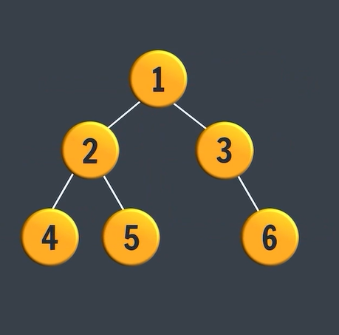
The height of a tree is the maximum distance between the root and the leaf in terms of nodes or in terms of edges.
Height in terms of nodes = No. of levels in the tree
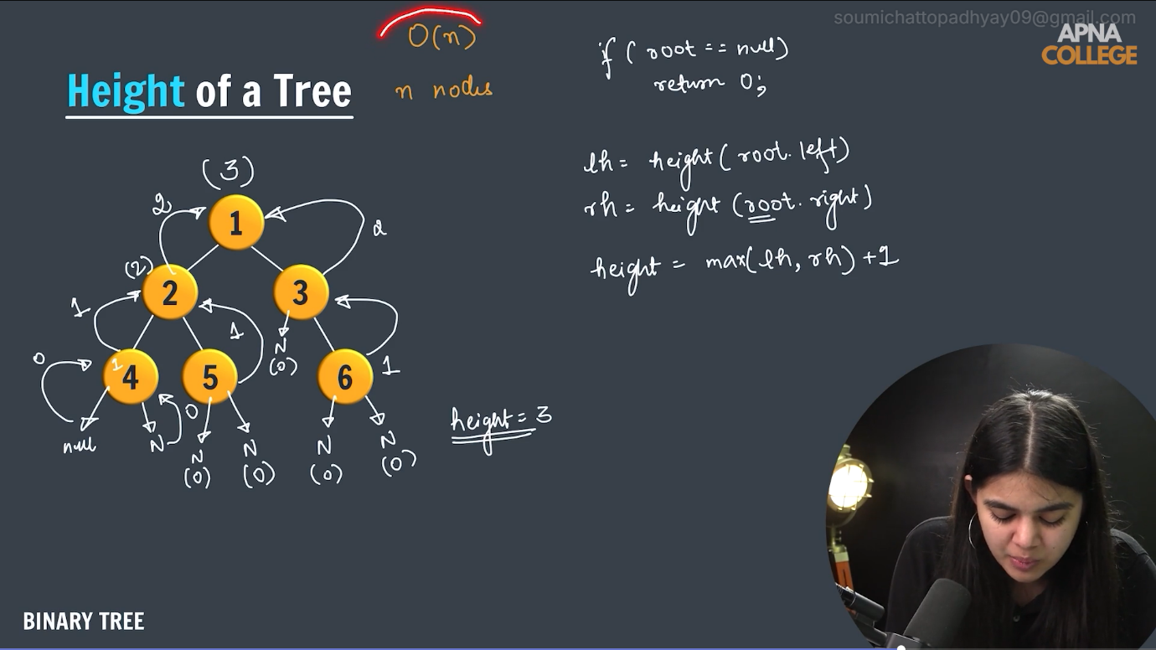
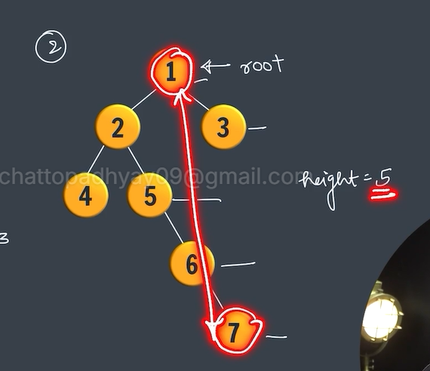
Here, height in terms of nodes = 3 = no. of levels
height in terms of edges = 2

We will find the height of the tree recursively. The child nodes would return their heights to the parent node. This way the left subtree and right subtree return their heights to the parent tree.

